**ITSP200 – DELIVERABLE 3**

|  |  |
| --- | --- |
| **Group Number & Name** | Group 4 – The Poll Makers |
| **Group Member Details** | BXMDLL7W9 – Mtshatsheni; Nompumelelo (Group Leader)  J6H6SY5M7 – Jansen; Nadine  P4PXK2T59 – Gumede; Luyanda |
| **Project Title** | Advanced Polling System |
| **Submission Date** | 22 August 2019 |
| **Signature of Group Leader** | N. Mtshatsheni |

Table of Contents

1. Information systems design 2

1.1 Logical design 2

1.1.1 Entity Relationship Diagram 2

1.1.2 Data Flow Diagram 3

1.2 Physical design 4

1.2.1 Investigation of technologies to be applied 4

1.2.2 System testing 4

A. Testing types 4

B. Testing templates 5

C. Test plan 15

1.2.3 System Interface Design 16

2. Customer sign-off 21

Reference 21

# Information systems design

## Logical design

When documenting information about a system design, logical will impact how a system somehow will carry its tasks, without giving an explanation to certain things like how, whom or where the tasks will take place.

(Connolly & Begg, Chapter 17)

## Entity Relationship Diagram

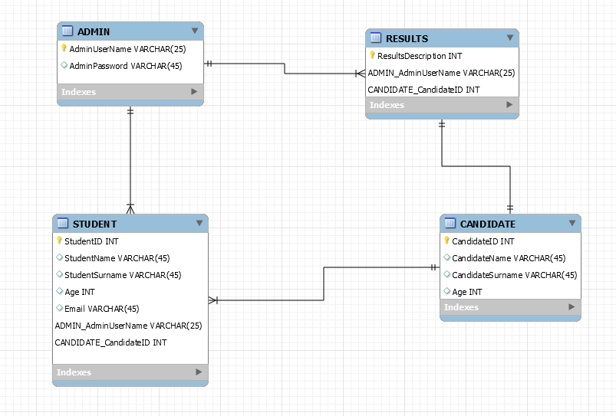

## Data Flow Diagram

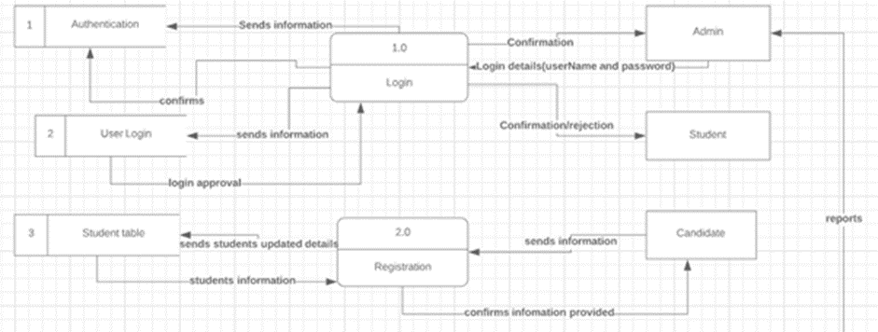

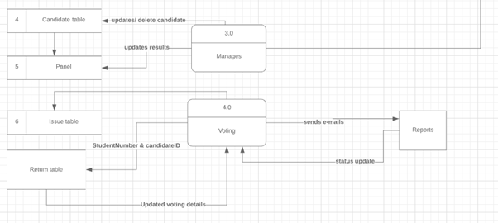

## Physical design

A physical design describes the system. It is known for storing and retrieving data that processes the input and how it displays the output.

## Investigation of technologies to be applied

The user interface design language used to develop and implement the APS is Java. Java needs a JDK (Java development kit) tools in order to write Java codes and programs. The JDK consists of the JRE (Java Runtime Environment) to run the Java application. the IDE (Integrated Development Environment) to write the Java code for the application.(Wintrich, 2017)

The Operating system that the computers in the library will have is Windows server 2008 R2 Enterprise. Windows server 2008 was developed by Microsoft, which was released in July 2009. Windows server 2008 R2 it enhances new hardware functionalities for Active Directory and virtualisation. The operating system runs on an intel processor with 2.67Ghz, the installed RAM is 32 GB and a 32-bit operating system or a 64-bit operating system. Windows server 2008 comes in multiple editions, such as Windows server 2008 R2 web, enterprise, foundation and standard.

MySQL workbench is an architect used for databases and data administrators. MySQL allows data administrators to manage, design and model databases. MySQL as well delivers visual tools for executing and optimising SQL queries, and visual tools for configuring servers and administration users.

(Guru, [online])

## System testing

## Testing types

System testing will test components of an application to see how each element works well together as a unit. (Pittet, 2019). A system must be tested thoroughly to cover all possible inputs, this way the system will be equipped to deal with as many possible real-life scenarios. The users experience with the system is very important because the system is designed for and to be used by the user. (ProfessionalQA, 2019).

The usability testing is one type of the testing systems types. When it comes to the usability testing is a way to see how easy to use something is by testing it with real users. Operators will be asked to complete errands, this involves that they will be detected through an investigator, to check if they able to come across difficulties and practice misperception. When users come across similar mix-up or the same mix-up keeps occurring repeatedly, certain approvals will be sent to resolve the usability problems.

System testing is part of black box testing. White box testing tests the written code of an application, when it comes to the white box testing it will breakdown the inner infrastructure of the entire system. The testing will start at the premature steps and more detailed and covering all the trails of the development. Whereas the black box testing tests are opposite to the white box testing. The test of the system is done in the view of the user which is why the application must be very user friendly (Geeks for geeks, 2018).

System testing is only done when the whole application has been completed (Software Testing Help, 2019). The whole application is tested thoroughly module by module. (Guru99, 2019).The unit testing of a system is when the testing is dividing among certain individuals to carry out the testing of certain mechanisms of the system. This is to confirm that everyone is performing the design interface at they own time. A unit testing is as minor part of a software, where it has many inputs going in and only release few outputs.

(Software Testing, Fundamentals, 2019).

## Testing templates

**Welcome screen**

|  |  |  |  |
| --- | --- | --- | --- |
| **No.** | **Test Description** | **Comments** | **Yes / No** |
| **1** | **Click ‘Register’ button and student register screen will be displayed.** |  |  |
| **2** | **Click ‘Admin’ button and the admin login screen will be displayed.** |  |  |

**Admin Login screen**

|  |  |  |  |
| --- | --- | --- | --- |
| **No.** | **Test Description** | **Comments** | **Yes / No** |
| **1** | **Click ‘Back’ button takes the user to ‘Welcome screen’** |  |  |
| **2** | **Enter username into ‘Admin Username’ text field.** |  |  |
| **3** | **Enter password into ‘Admin Password’ text field.** |  |  |
| **4** | **Enter ‘Login’ button to verify admin details through database.** |  |  |
| **5** | **Appropriate error message is displayed when username or password is incorrect.** |  |  |
| **6** | **‘Admin Username’ and ‘Admin Password’ are cleared for user to re-attempt login.** |  |  |
| **7** | **Click ‘Login’ button and the ‘Database screen’ are displayed.** |  |  |

**Register screen**

|  |  |  |  |
| --- | --- | --- | --- |
| **No.** | **Test Description** | **Comments** | **Yes / No** |
| **1** | **Click ‘Back’ button and it will return user to ‘Welcome screen’.** |  |  |
| **2** | **User should enter all data into required text fields.** |  |  |
| **3** | **Appropriate error messages provided for any missing fields.** |  |  |
| **4** | **Click ‘Next’ button and student login screen will be displayed.** |  |  |

**Student Login screen**

|  |  |  |  |
| --- | --- | --- | --- |
| **No.** | **Test Description** | **Comments** | **Yes / No** |
| **1** | **Click ‘Back’ button and will return user to ‘Register screen’.** |  |  |
| **2** | **Enter data into the student number text field.** |  |  |
| **3** | **Enter data into the password text field.** |  |  |
| **4** | **Click ‘Login’ button, which checks if student information matches to the database information.** |  |  |
| **5** | **An appropriate error message is displayed if any incorrect password or student number are used.** |  |  |
| **6** | **When incorrect login details are used, the login screen will clear all data and allow students to re-login.** |  |  |

**Database screen**

|  |  |  |  |
| --- | --- | --- | --- |
| **No.** | **Test Description** | **Comments** | **Yes / No** |
| **1** | **Click ‘Back’ button which returns user to ‘Admin Login screen’.** |  |  |
| **2** | **A drop box that are populated with relevant data.** |  |  |
| **3** | **Select ‘Candidate Information’ from drop-box to view information of all candidates in the database** |  |  |
| **4** | **Select ‘Student Information’ from drop-box to view all students' information in the database.** |  |  |
| **5** | **Select ‘Count Vote’ from drop-box to display all recorded number of votes.** |  |  |
| **6** | **Select ‘Vote Result’ from drop-box to display the winner of the election.** |  |  |
| **7** | **Click ‘Next’ button to display the choice selected screen.** |  |  |

**Candidate Information**

|  |  |  |  |
| --- | --- | --- | --- |
| **No.** | **Test Description** | **Comments** | **Yes / No** |
| **1** | **Click ‘Back’ button to return to ‘Database screen’.** |  |  |
| **2** | **A populated table with relevant information is displayed.** |  |  |
| **3** | **All the candidate’s information is displayed from the database.** |  |  |

**Student Information**

|  |  |  |  |
| --- | --- | --- | --- |
| **No.** | **Test Description** | **Comments** | **Yes / No** |
| **1** | **Click ‘Back’ button to return to ‘Database screen’.** |  |  |
| **2** | **A populated table with relevant information is displayed.** |  |  |
| **3** | **All the student’s information is displayed from the database.** |  |  |

**Voting Screen**

|  |  |  |  |
| --- | --- | --- | --- |
| **No.** | **Test Description** | **Comments** | **Yes / No** |
| **1** | **Click ‘Back’ button returns user to ‘Student login screen’** |  |  |
| **2** | **Check boxes are used to select a suitable candidate.** |  |  |
| **3** | **Error messages are displayed when more than one checkbox was selected.** |  |  |
| **4** | **When only one checkbox was selected the vote will be verified by the database.** |  |  |
| **5** | **When ‘Submit vote’ is selected all votes are recorded and ‘Finish screen’ will be displayed.** |  |  |
| **6** | **If login details are correct, the ‘Voting’ screen is displayed.** |  |  |

**Finish screen**

|  |  |  |  |
| --- | --- | --- | --- |
| **No.** | **Test Description** | **Comments** | **Yes / No** |
| **1** | **An appropriate message is displayed that informs the student the vote has been processed and completed.** |  |  |
| **2** | **An appropriate message will display that after all votes are recorded, the student will receive the winner through an email.** |  |  |
| **3** | **Click ‘Exit’ button and the ‘Welcome screen’ will be displayed.** |  |  |

**Count Vote**

|  |  |  |  |
| --- | --- | --- | --- |
| **No.** | **Test Description** | **Comments** | **Yes / No** |
| **1** | **Click ‘Back’ button to return to ‘Database screen’.** |  |  |
| **2** | **Two populated tables are displayed with relevant information.** |  |  |
| **3** | **All candidate’s information is displayed in one table and the total of votes of each candidate are displayed in the second table.** |  |  |

**Vote Result**

|  |  |  |  |
| --- | --- | --- | --- |
| **No.** | **Test Description** | **Comments** | **Yes / No** |
| **1** | **Click ‘Back’ button to return to ‘Database screen’.** |  |  |
| **2** | **Populated table are displayed of the winning candidate’s information and the total amount of votes.** |  |  |
| **3** | **Click ‘Next’ button and the ‘Finish screen’ will appear with relevant information.** |  |  |

**Finish screen**

|  |  |  |  |
| --- | --- | --- | --- |
| **No.** | **Test Description** | **Comments** | **Yes / No** |
| **1** | **An appropriate message is displayed, that each student is emailed which announces the winner of the election.** |  |  |
| **2** | **Click ‘Exit’ button to return to ‘Welcome screen’.** |  |  |

**Email Report**

|  |  |  |  |
| --- | --- | --- | --- |
| **No.** | **Test Description** | **Comments** | **Yes / No** |
| **1** | **An email that are sent to each student, containing the winner.** |  |  |
| **2** | **An email that are sent to each candidate.** |  |  |

## Test plan

|  |  |  |  |
| --- | --- | --- | --- |
| **Test Plan – This are all the testing that will be done during the development.** | | | |
| **Test type** | **Test Date** | **Team Members** | **Feedback** |
| **Welcome screen** | **20 September 2019** | **Nadine & Nompumelelo** |  |
| **Register screen** | **20 September 2019** | **Nadine & Nompumelelo** |  |
| **Student Login Screen** | **20 September 2019** | **Nadine & Nompumelelo** |  |
| **Voting Screen** | **20 September 2019** | **Nadine & Nompumelelo** |  |
| **Finish Screen** | **20 September 2019** | **Nadine & Nompumelelo** |  |
| **Admin Screen** | **20 September 2019** | **Nadine & Nompumelelo** |  |
| **Database Screen** | **20 September 2019** | **Nadine & Nompumelelo** |  |
| **Candidate Information** | **20 September 2019** | **Nadine & Nompumelelo** |  |
| **Student Information** | **20 September 2019** | **Nadine & Nompumelelo** |  |
| **Count Vote** | **20 September 2019** | **Nadine & Nompumelelo** |  |
| **Vote Result** | **20 September 2019** | **Nadine & Nompumelelo** |  |
| **Finish Screen** | **20 September 2019** | **Nadine & Nompumelelo** |  |
| **Email Report** | **20 September 2019** | **Nadine & Nompumelelo** |  |

## System Interface Design

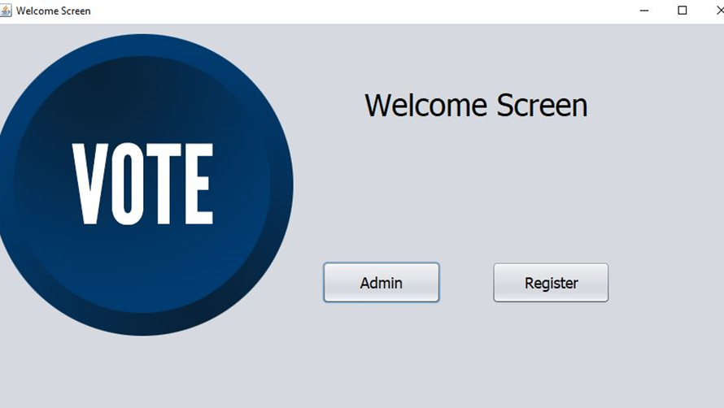

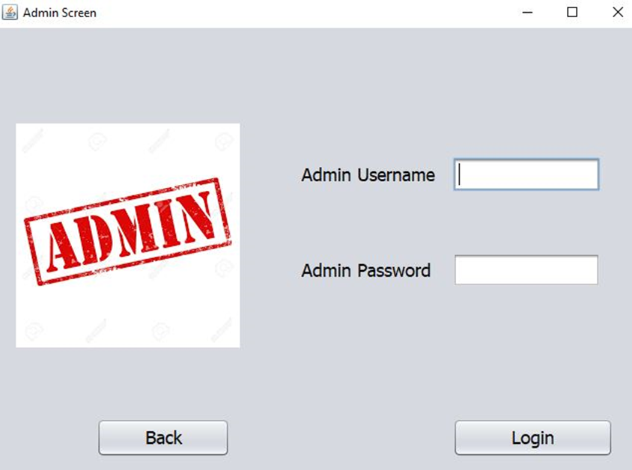

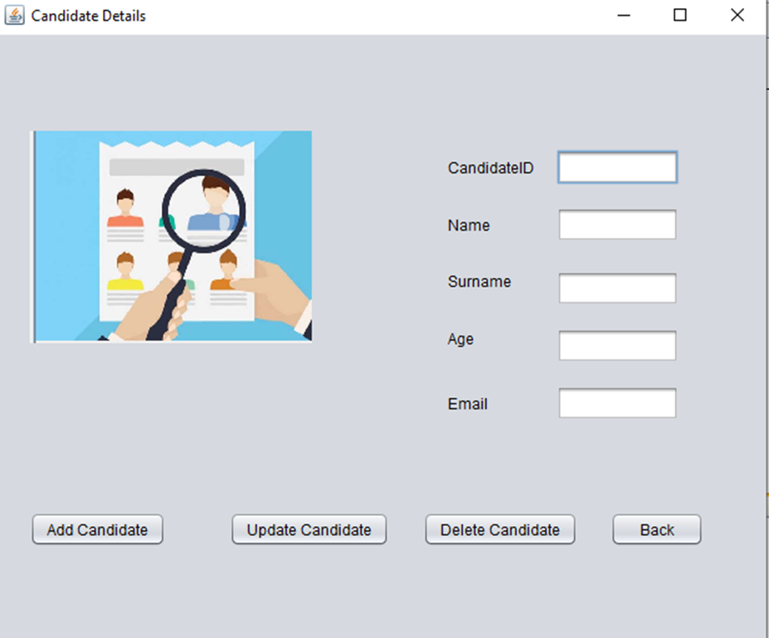

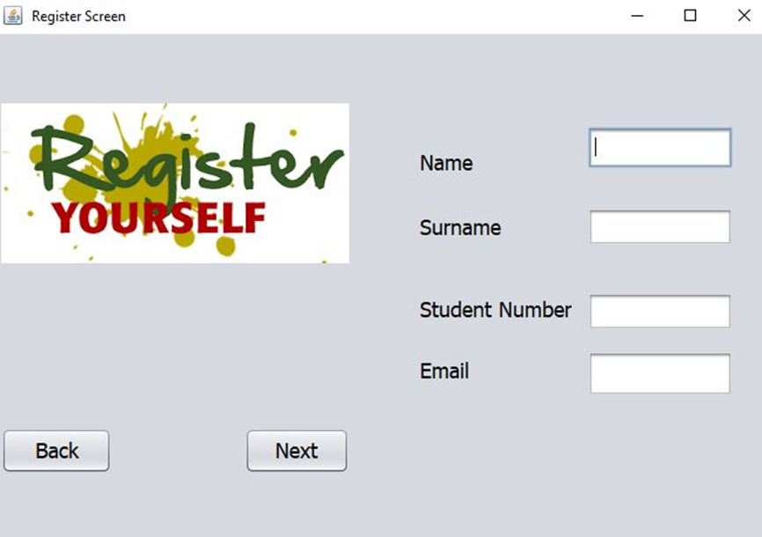

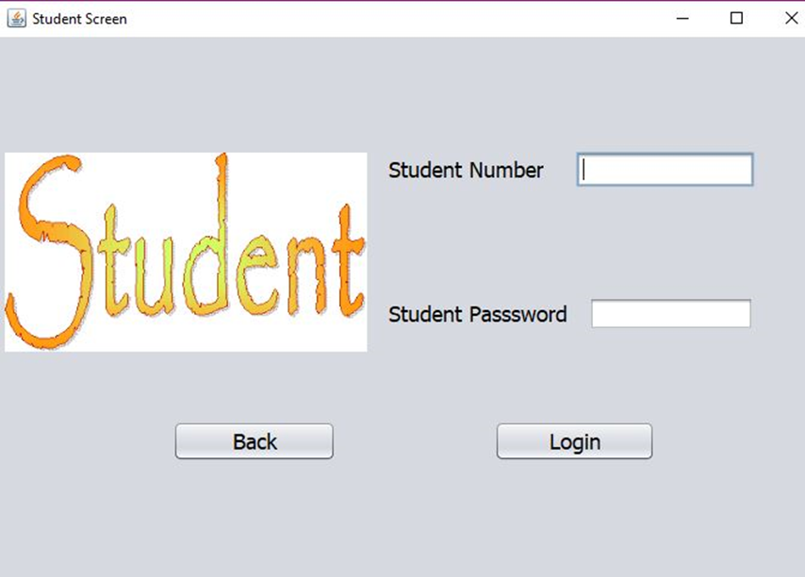

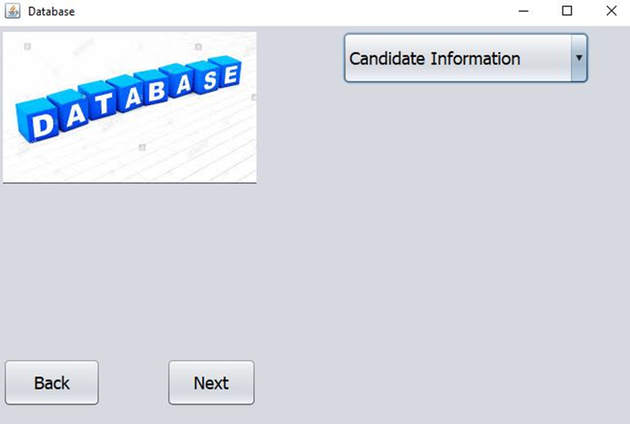

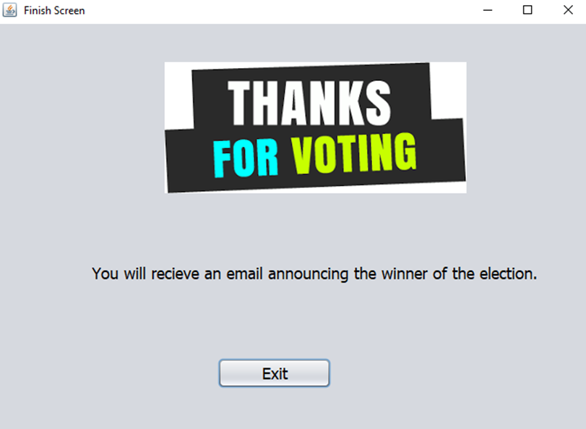



# Customer sign-off

|  |  |
| --- | --- |
| **Customer name and surname** | **Customer signature** |
| **Group leader name and surname**  **Nompumelelo Mtshatsheni** | **Group leader signature**  **N.Mtshatsheni** |

# Reference

Connolly, T & Begg, C. 2015. Database System: A Practical Approach to Design, Implementation and Management. 6th Edition. Pearson Education

Wintrich, D. 2017. Java: What Beginners Need to Know Now. Available: <https://www.coursereport.com/blog/what-is-java-programming-used-for> [Accessed August 2019]

<https://www.guru99.com/introduction-to-mysql-workbench.html>

Geeks for geeks, 2018. *Types of Software Testing.* [Online] Available at: <https://www.geeksforgeeks.org/types-software-testing/> [Accessed August 2019].

Guru99, 2019. *What is System Testing? Types & Definition with Example.* [Online] Available at: <https://www.guru99.com/system-testing.html> [Accessed August 2019].

Software Testing: Fundamentals [Online] Available at: <http://softwaretestingfundamentals.com/white-box-testing/> [Accessed August 2019]

Pittet, S., 2019. *The different types of software testing.* [Online] Available at: <https://www.atlassian.com/continuous-delivery/software-testing/types-of-software-testing> [Accessed August 2019].

ProfessionalQA, 2019. *System Testing.* [Online] Available at: <http://www.professionalqa.com/system-testing> [Accessed August 2019].

Software Testing Help, 2019. *What Is System Testing – A Ultimate Beginner’s Guide.* [Online] Available at: <https://www.softwaretestinghelp.com/system-testing/> [Accessed August 2019].